

Placement Empowerment Program
Cloud Computing and DevOps Centre

Classic Load Balancer & Auto Scaling in AWS

Name: Indhumathi S Department : CSE



Introduction:
In today's PoC, I worked on implementing Classic Load Balancer (CLB) and Auto Scaling in AWS to ensure efficient traffic distribution and automatic resource management.
What is Load Balancer?
A Load Balancer in AWS is a service that automatically distributes incoming traffic across multiple targets (such as EC2 instances, containers, and IP addresses) in different Availability Zones to ensure high availability, fault tolerance, and scalability.

What is Auto Scaling?
Auto Scaling in AWS is a feature that automatically adjusts the number of EC2 instances in response to traffic demand. It ensures that the right number of instances are running to handle the load efficiently, reducing costs and improving availability.

Benefits:
✅ 1. Hands-on Experience with Load Balancing
- Understands how Classic Load Balancer (CLB) distributes traffic across multiple EC2 instances.
- Ensures high availability and fault tolerance.
✅ 2. Improved Understanding of Auto Scaling
- Learns how to dynamically scale EC2 instances based on real-time demand.
- Ensures applications run efficiently without manual intervention.
✅ 3. Cost Optimization
- Prevents over-provisioning by scaling down instances when demand is low.
- Ensures cost-efficient resource management.
✅ 6. Real-World Cloud Deployment Skills
- Builds practical skills useful for cloud-based applications and DevOps.
- Prepares for AWS certification exams and real-world projects.

Step-by-Step Overview
Step1: Log in to AWS Console
1.Go to AWS Management Console.
2. Navigate to EC2.
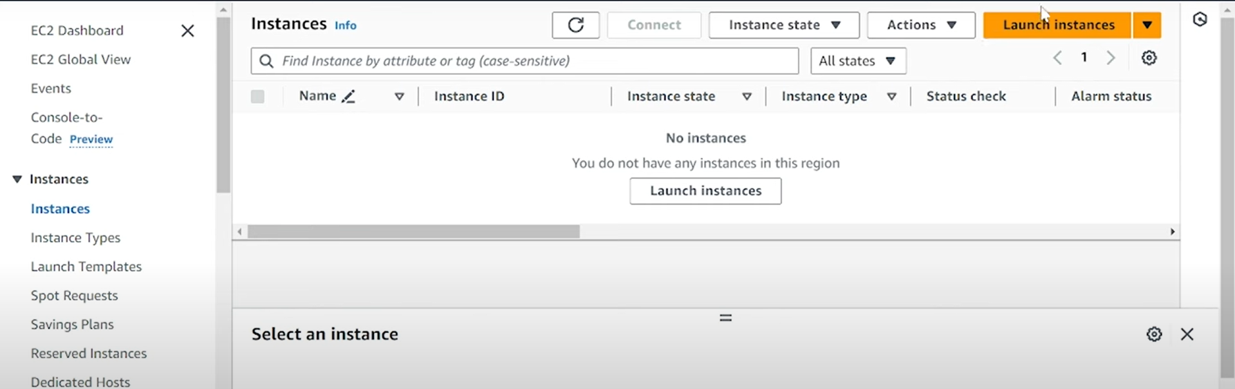
Step 2 :Create Two EC2 Instances
- In the EC2 Dashboard, click Launch Instances.
- 2. Choose an Amazon Linux 2 or Ubuntu AMI.
- 3. Select t2.micro (free tier eligible).
4. Configure the instance: • Number of instances: 2 • Keep default settings. 5. Add User Data (optional) to install a web server: • In Advanced Details, under User Data, enter:
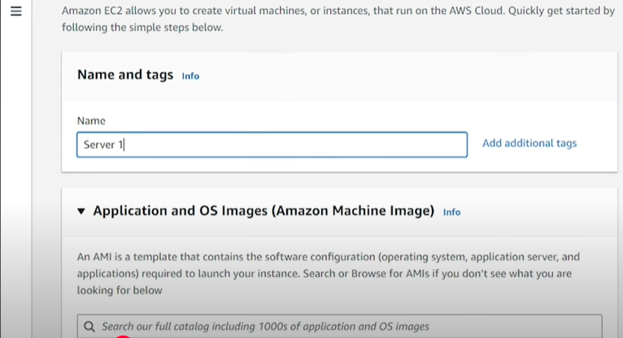
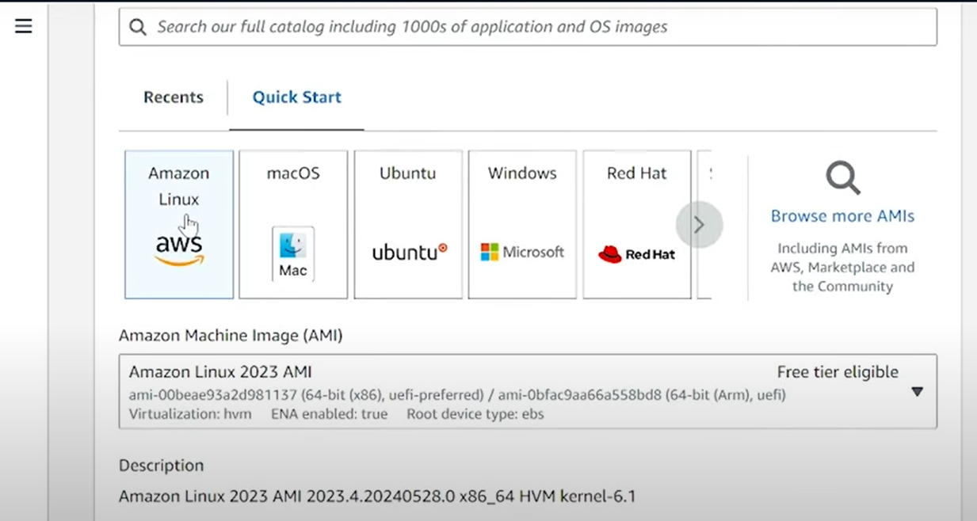

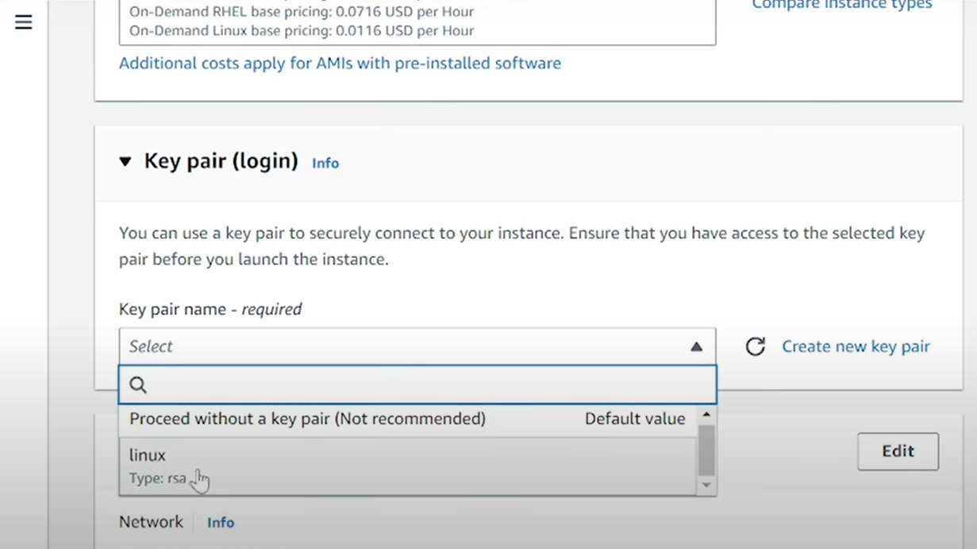
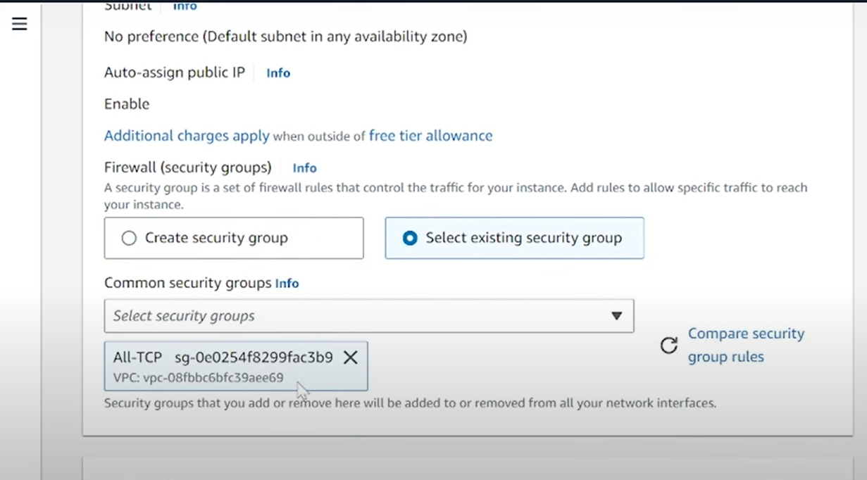

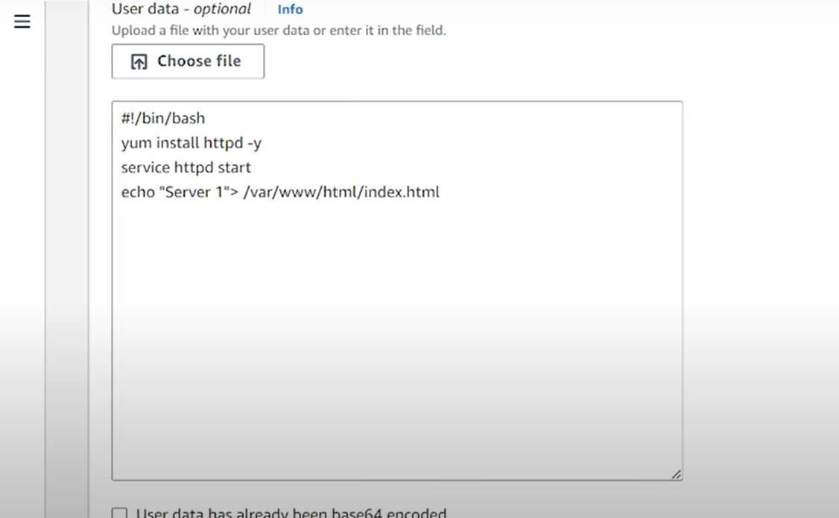
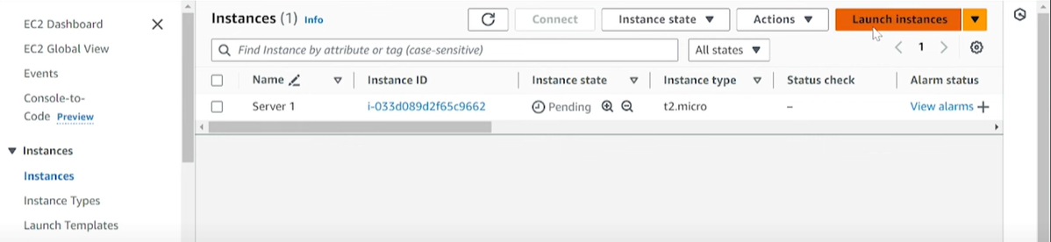
Step 3 :
For Server 2, follow the same steps, but modify the User Data script to display a different message.
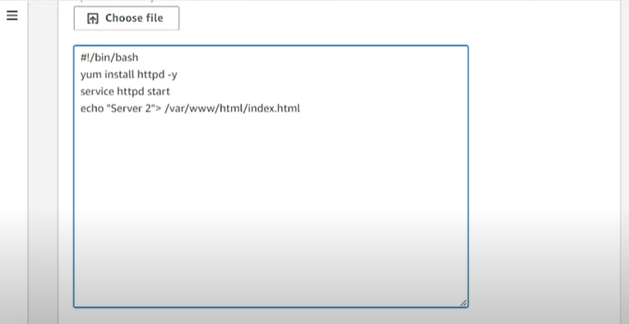
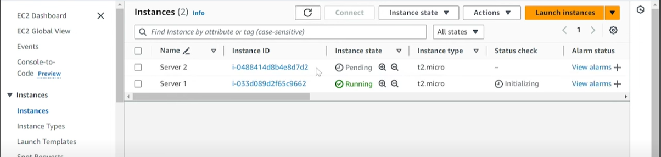
Step 4 :

Select Load Balancer Type
- Choose "Classic Load Balancer."
- Click "Create."

Configure Load Balancer Settings
- Name: Enter a unique name (e.g., MyClassicLB).
- Scheme: Select Internet-facing (for public access) or Internal (for private use).
- Listener Configuration:
  - Protocol: HTTP
  - Port: 80 (default for web traffic)
- VPC & Availability Zones:
  - Choose a VPC where your EC2 instances are running.
  - Select at least two Availability Zones for high availability.
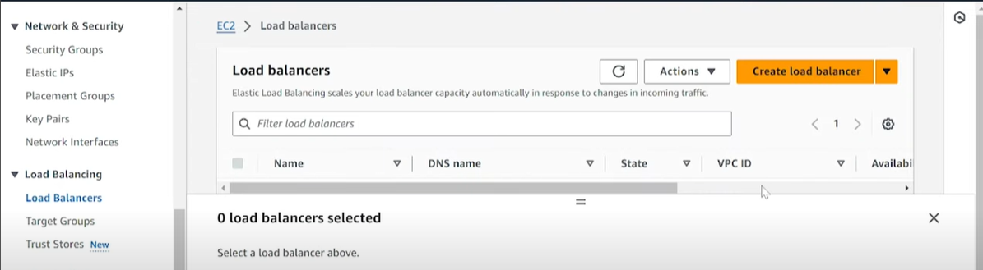
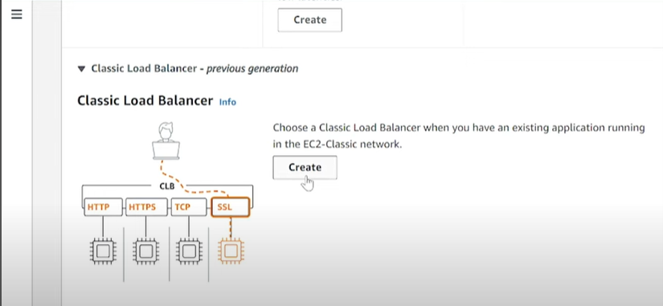
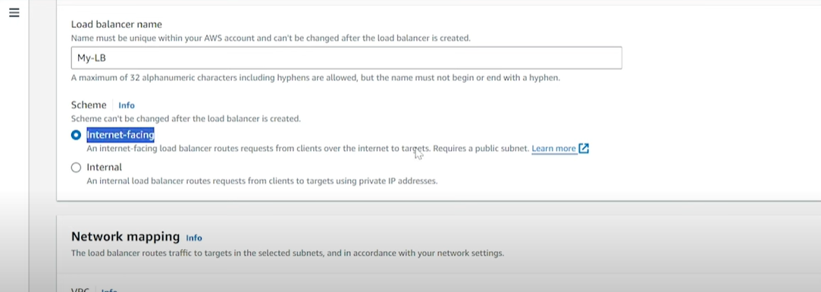
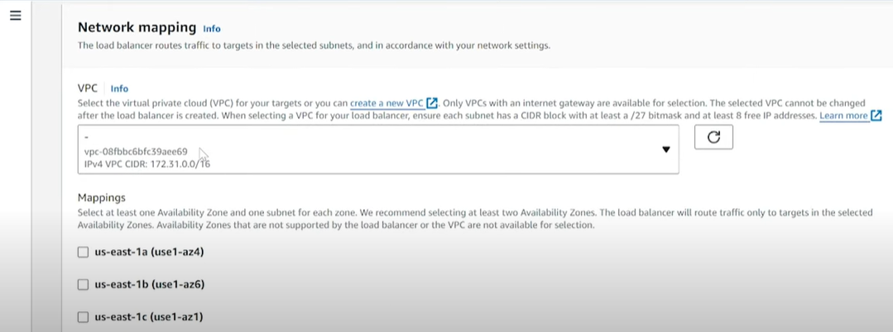
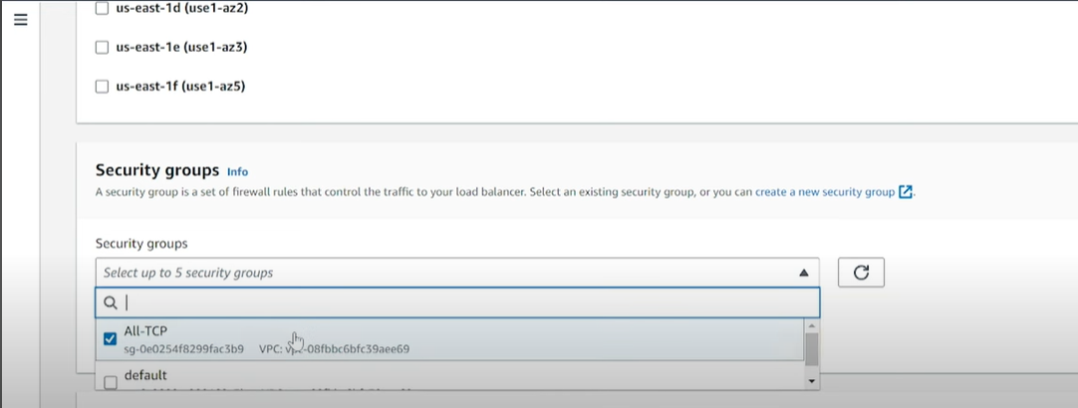
Step 5 :
Copy the DNS Name of your Load Balancer.
- Open a web browser and paste the DNS link in the address bar.
- For example, http://myclassiclb-1234567890.us-west-2.elb.amazonaws.com.

Verify the Web Server Output
- If the Load Balancer is correctly configured, the browser should show the web page from one of the EC2 instances (e.g., Server 1 or Server 2).
- Refresh the page multiple times. You should see the page alternate between Server 1 and Server 2 (depending on the load balancing).
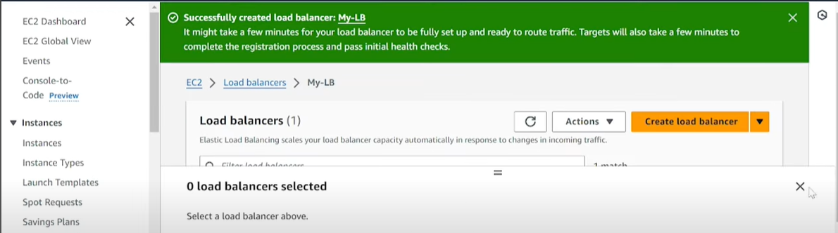
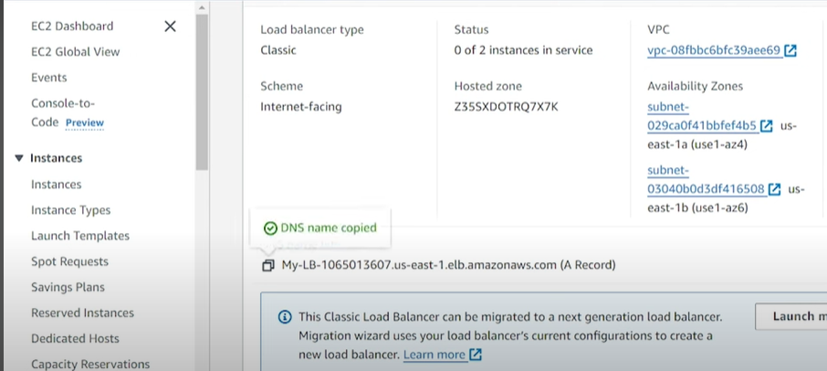
Step 6 :

Create Launch Template
- In the Launch Templates section, click Create launch template.
- Fill in the following information:
  - Template Name: My-Template.
  - Template Version Description: My-Template.
  - AMI ID: Choose the Amazon Linux 2 or Ubuntu AMI you selected for Server 1 and Server 2.
  - Instance Type: t2.micro (or any other type that fits your needs).
  - Key Pair: Select an existing key pair or create a new one for SSH access.
  - Network: Select the VPC you are using (ensure both EC2 instances are in the same VPC).
  - Subnet: Choose a subnet or use the default.
  - Security Group: Select the security group that allows HTTP (port 80) and HTTPS (port 443).
  - IAM Role (Optional): Select if needed.
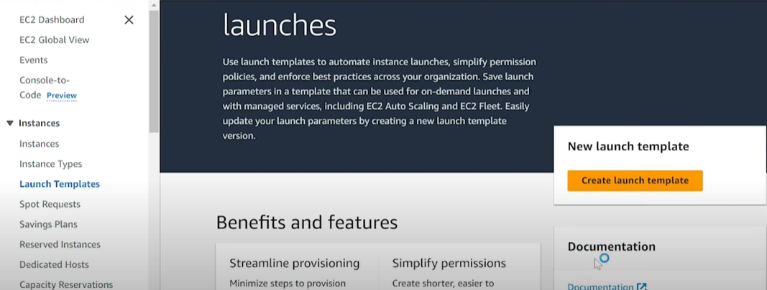
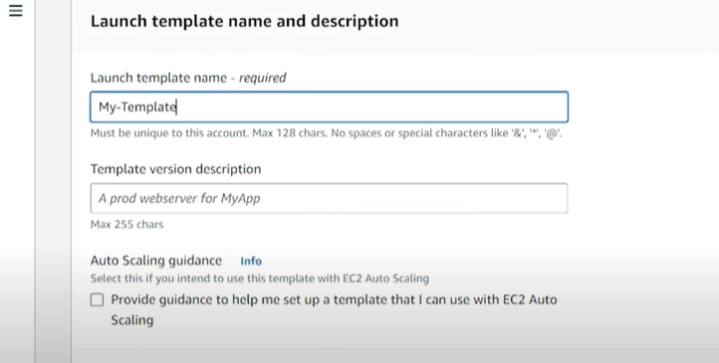
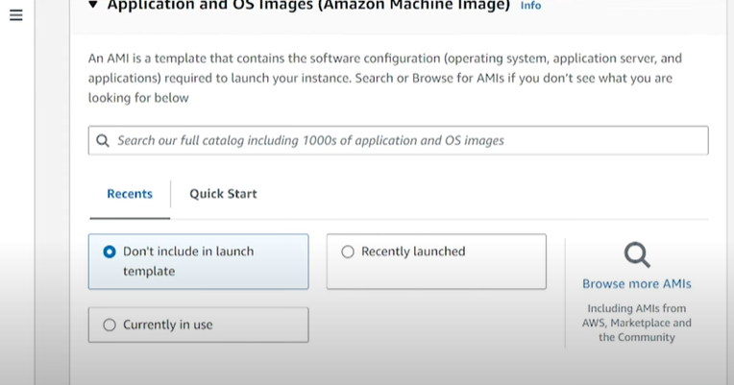
Step 7 :

Creating AMI for Server 1
- Log in to AWS Console and navigate to EC2.
- In the Instances section, select Server 1.
- Click on Actions → Image and templates → Create image.
  - Provide a name for the image (e.g., Server1-AMI).
  - Optionally, add a description.
  - Select No Reboot if you do not want to reboot the instance.
- Click Create Image and wait for the image creation to complete.
- Once ready, the AMI will be available in the AMIs section under Images.
Or Creating AMI for Server 2
- Select Server 2 in the Instances section.
- Repeat the same steps:
  - Click Actions → Image and templates → Create image.
  - Name the image (e.g., Server2-AMI).
- Click Create Image and wait for the process to complete.
- Server 2's AMI will appear in the AMIs section once ready.
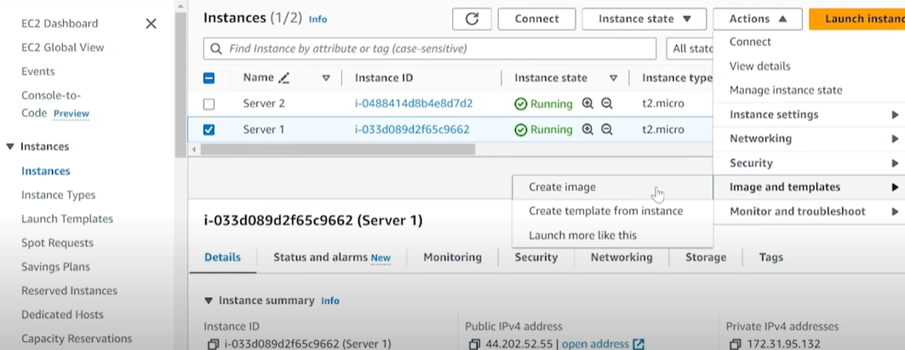
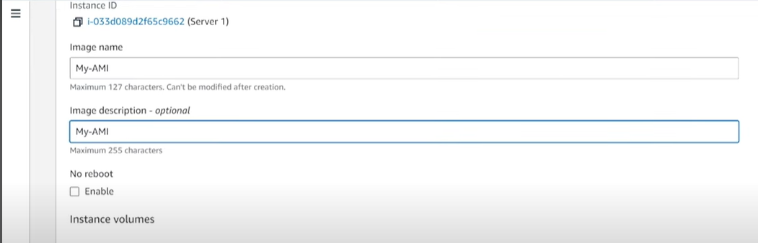
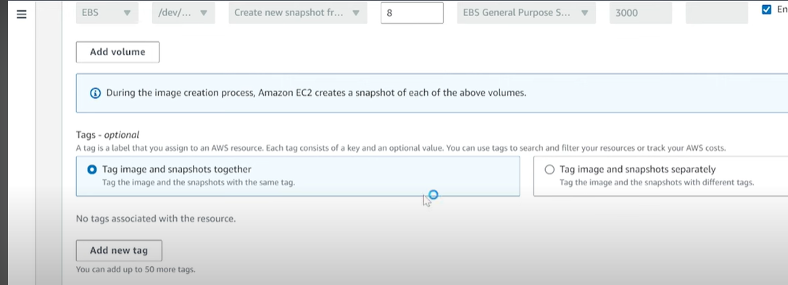
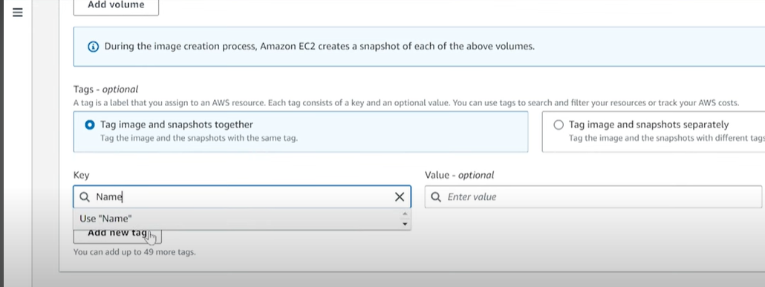

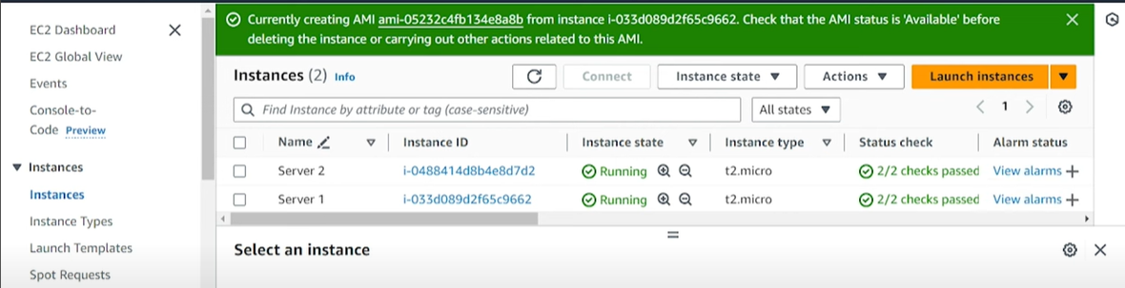
Step 9 :
Create Launch Template follows Step 6 as a continue. Name : Server 3
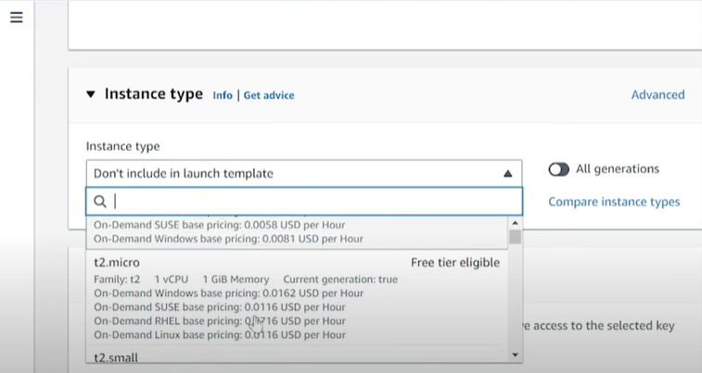

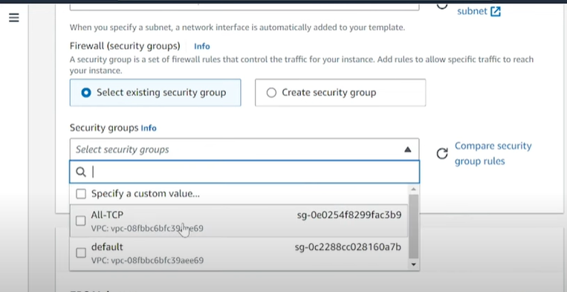
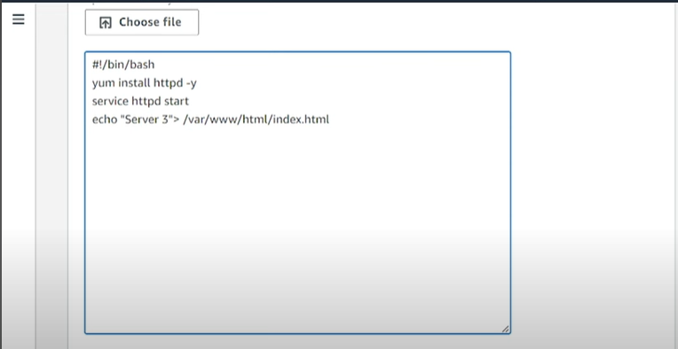
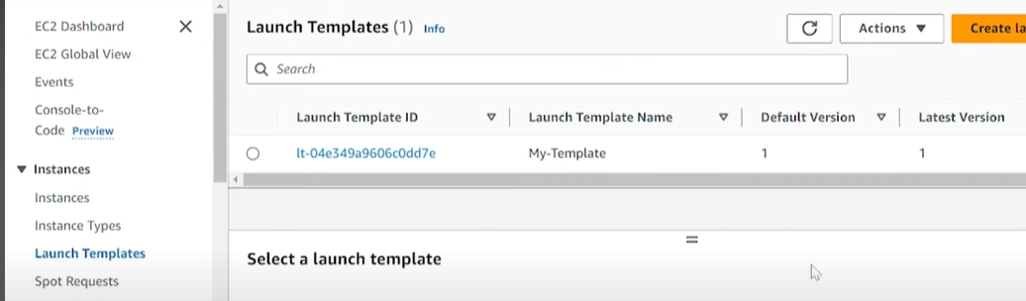
Step 9 :
Create AutoScaling Groups.
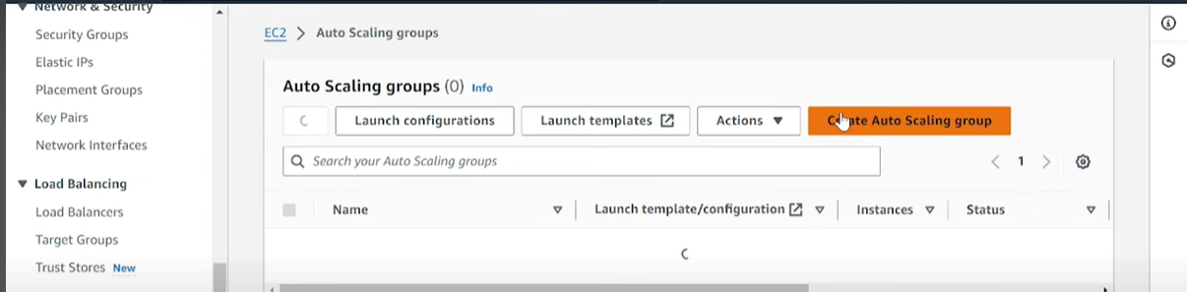
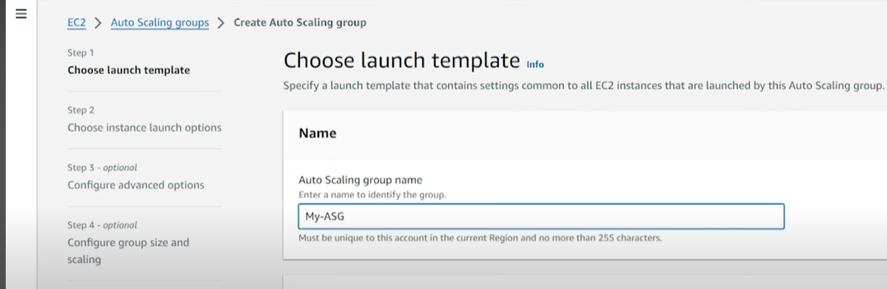
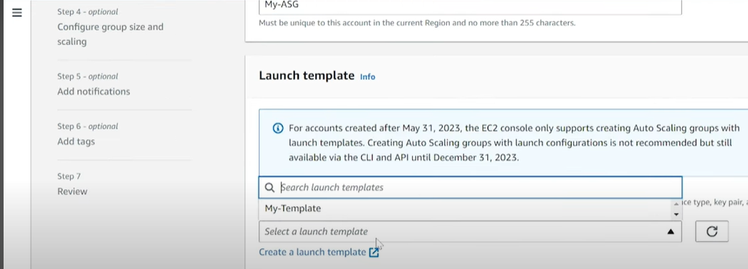
Click next..

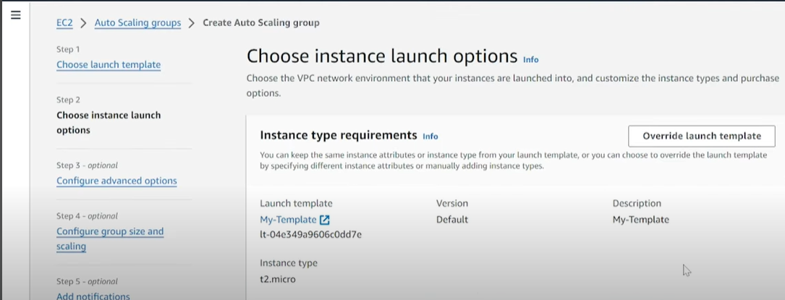

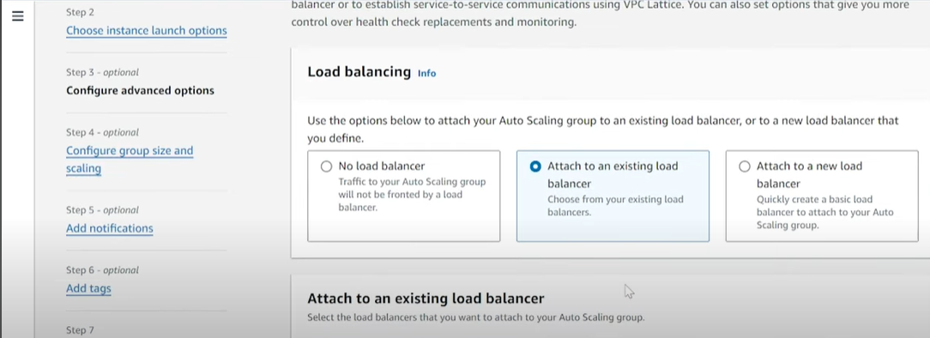
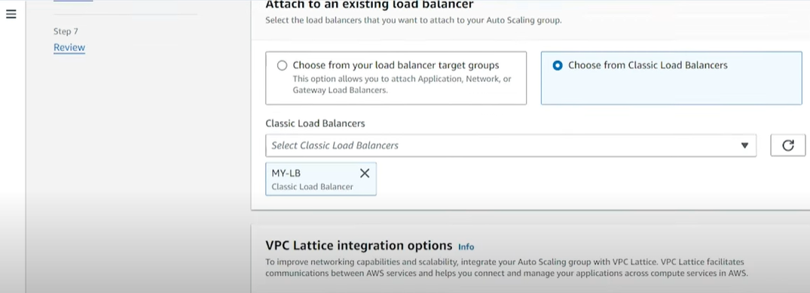

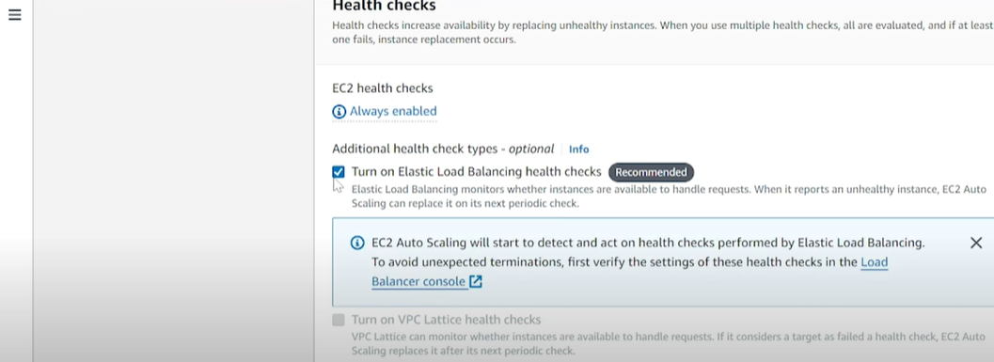
Click Next...
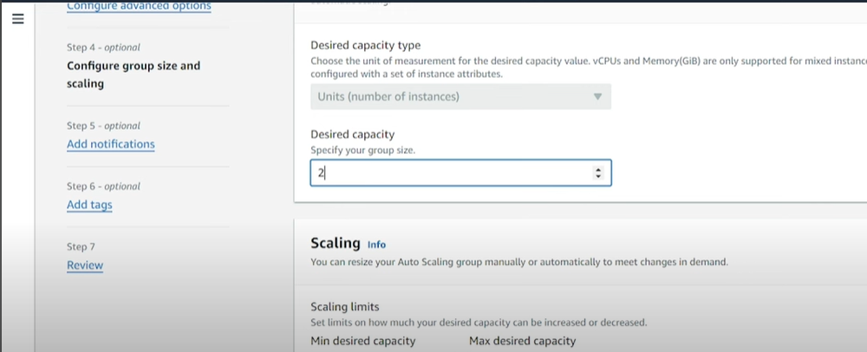
After this step all are default and chlick next..
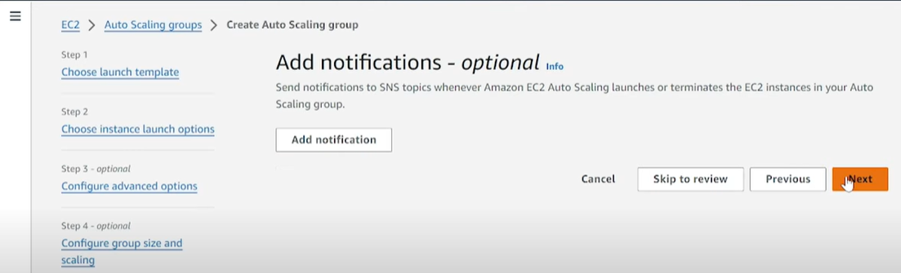
click Next and click Creat auto scaling Groups.

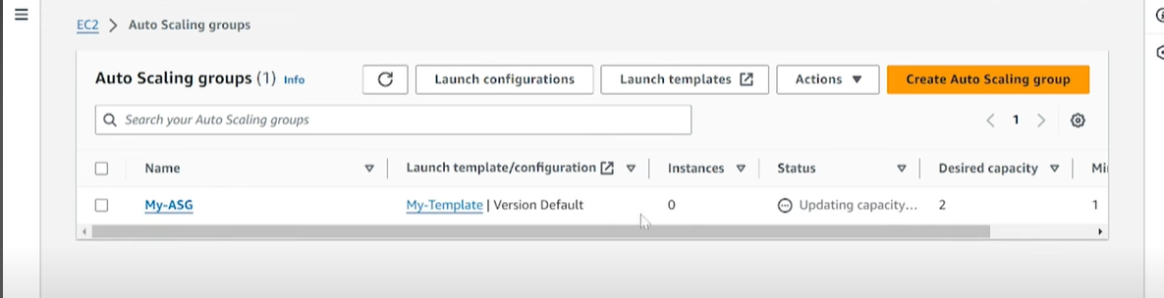
Step 10:
Go to EC2 instance there will running another 2 servers with the name of SERVER 3 which we given in the Launch Template.
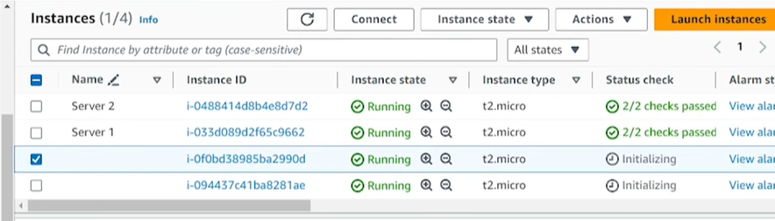
Run the public IP address in the web browser, and it will display Server 3. Now, go to the Load Balancer, copy the DNS URL, and paste it into the web browser.

In this PoC, how do we route the servers using a load balancer .
If the instances are reloaded repeatedly, the servers may get terminated.

Outcome:

Accessing EC2 Public IP
- When you enter the public IP address of any EC2 instance (e.g., Server 1, Server 2, or Server 3) in a web browser, it should display the corresponding server name.

Testing Load Balancer DNS
- When you enter the Load Balancer DNS URL in a web browser, it should route requests to different servers based on round-robin or health check rules.

*The output should change depending on which server the Load Balancer directs traffic to.
Verifying Traffic Distribution
- When checking the Load Balancer Target Group, the status of instances should show Healthy.
- If any instance is unhealthy, it should be replaced based on the Auto Scaling Group policy.

